Add custom field ’Priority’ to test project, this script will fill the Priority base on Importance.

Make sure the size of xml file is less than 350KB

Export Test suite

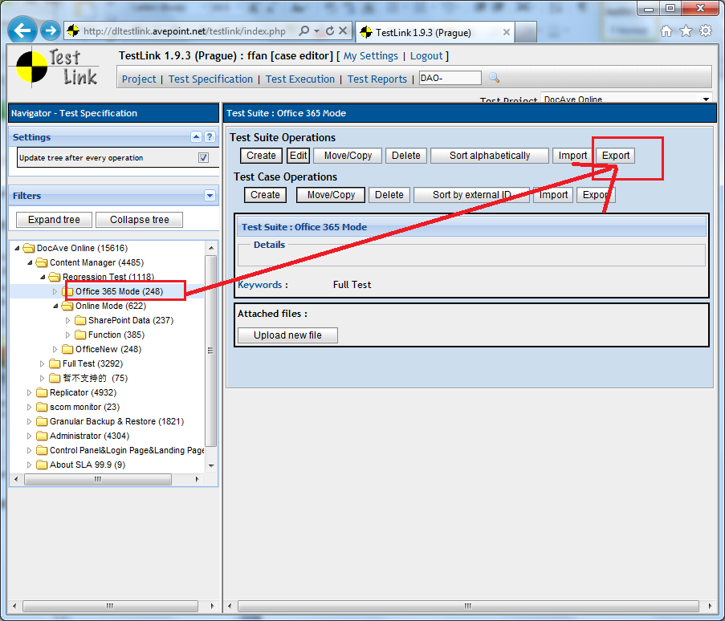

Export test suite with Custom fields

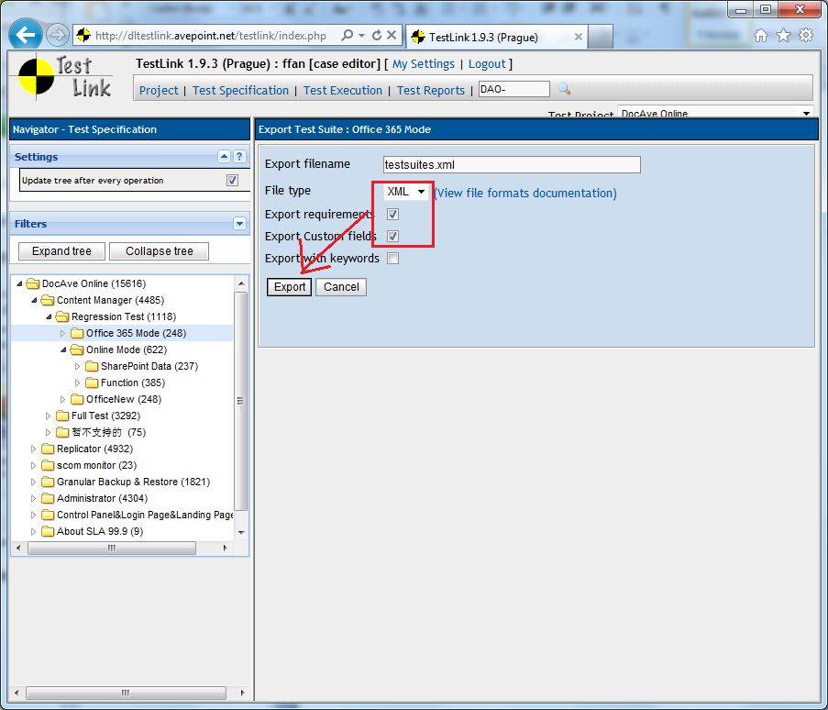

Open testsuites.xml with IE, and save it as ‘txt’ file.

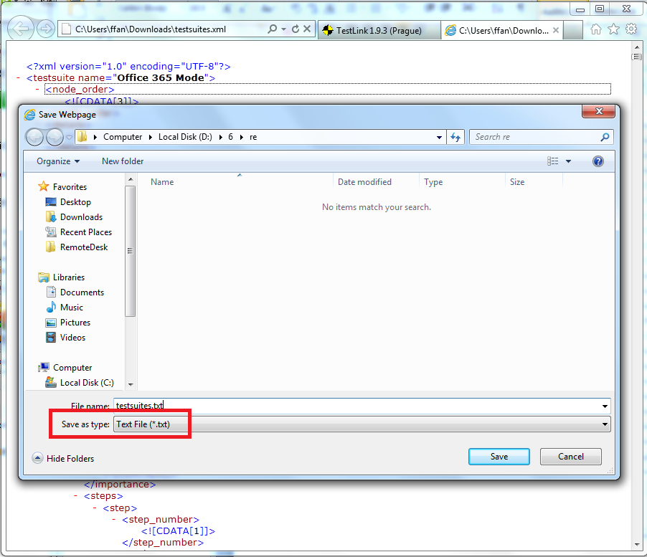

Edit testsuites.txt, delete useless content.

The space line before ‘<?xml version="1.0" encoding="UTF-8"?>’ and the content between ’

<?xml version="1.0" encoding="UTF-8"?>’ and ‘<testsuites…’.

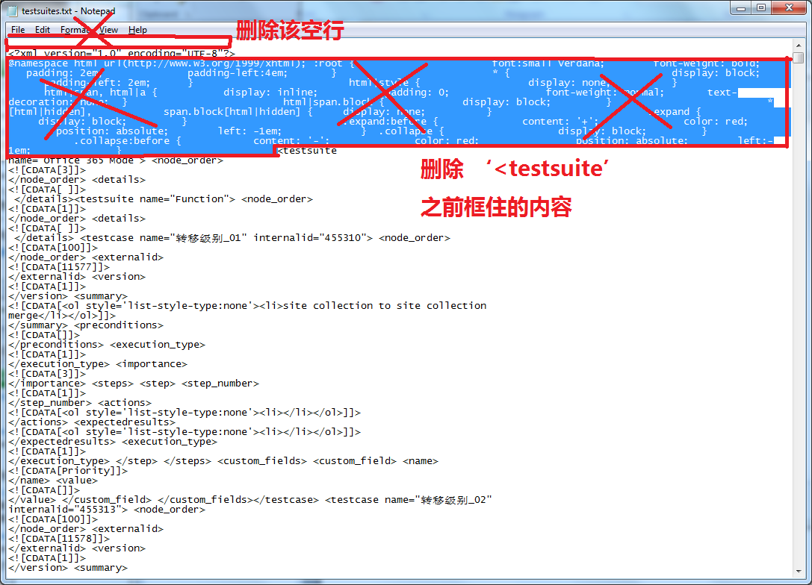

Change the ‘testsuites.txt’ to ‘testsuites.xml’

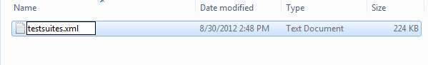

Run the script